GitHub Tutorial



# Creating a New Repository

* Register yourself with GitHub
* Install GitHub client from http://windows.github.com or http://mac.github.com
* Create a new Reposity and name it CommJExperiment
* Go to the client GitHub user interface and refresh from the bottom of the window

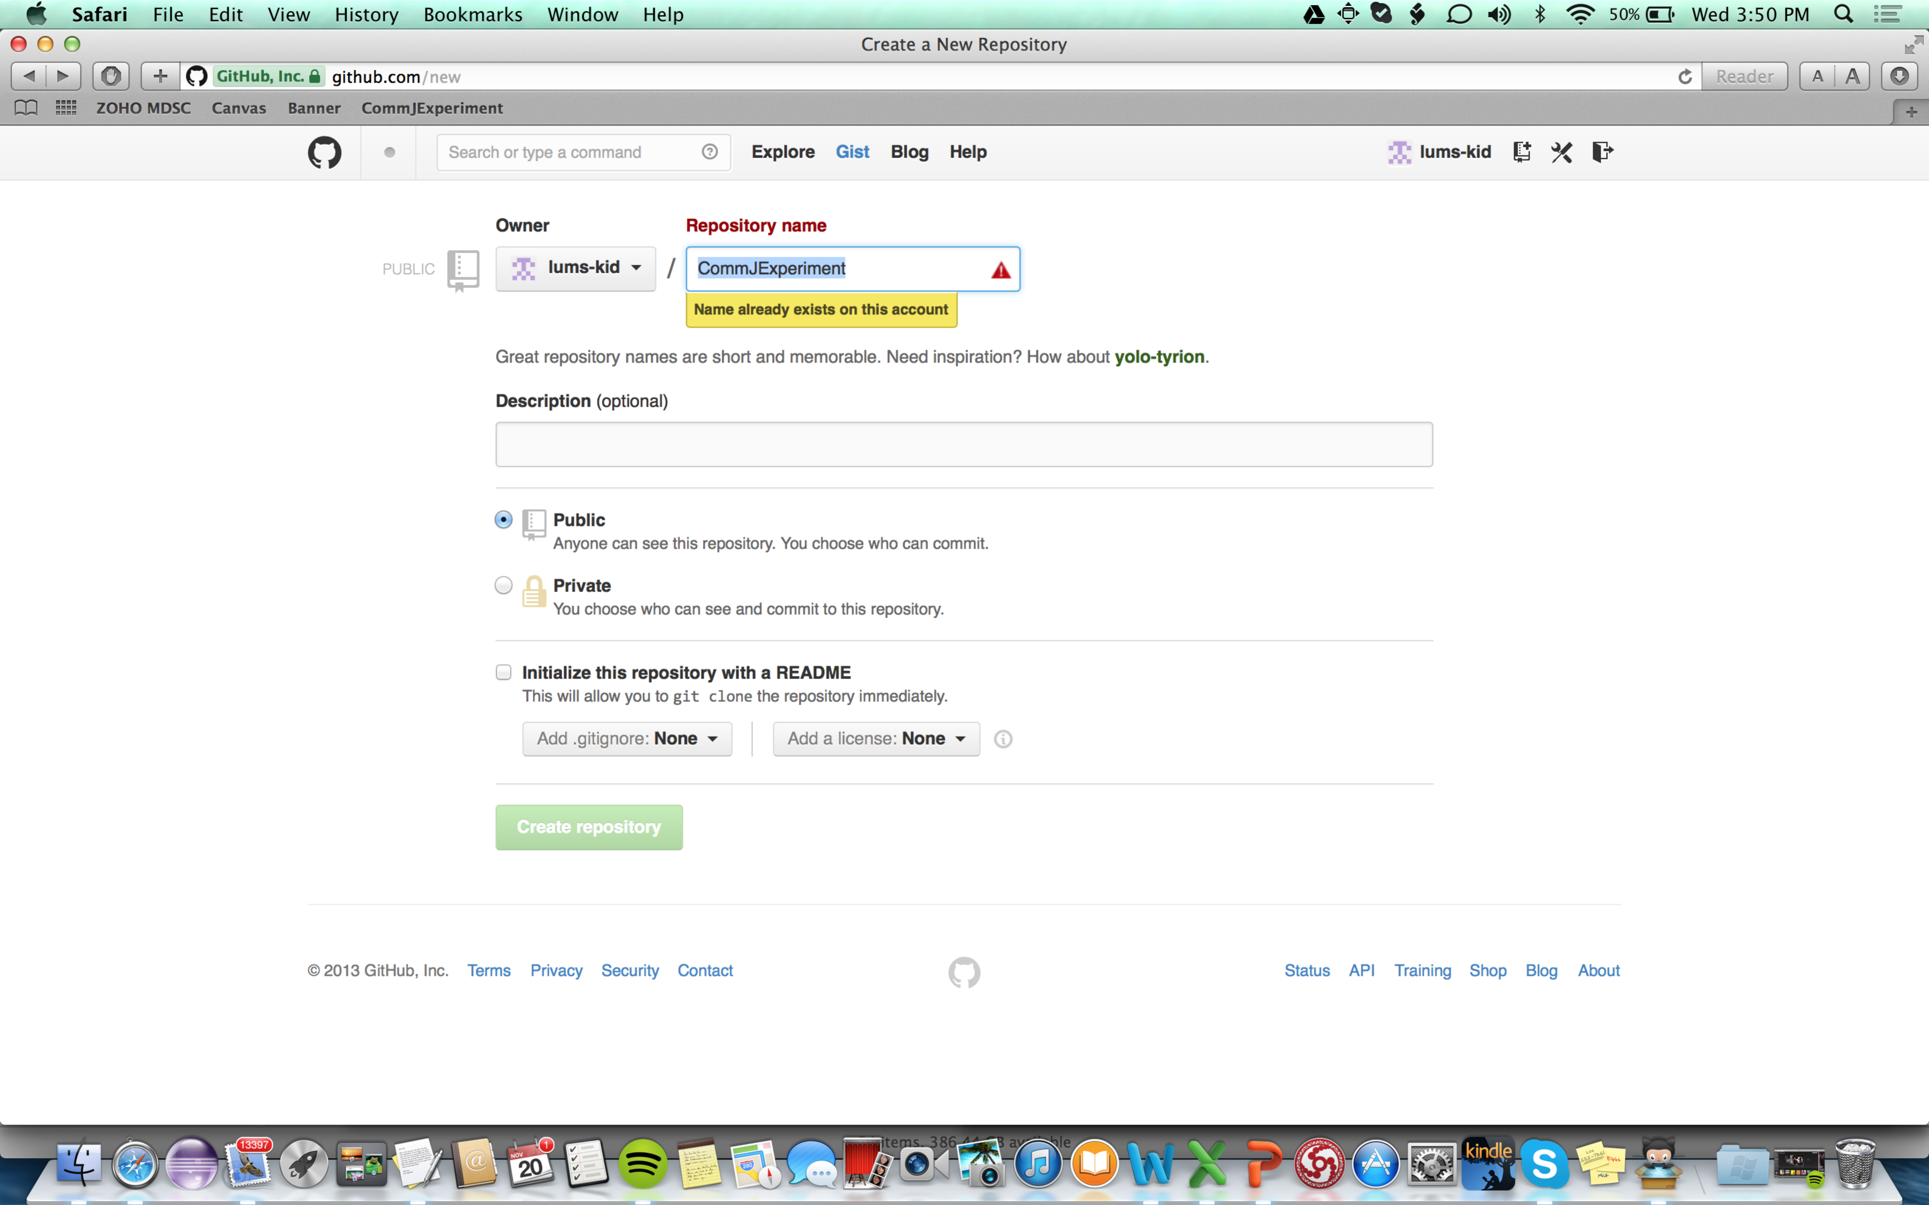

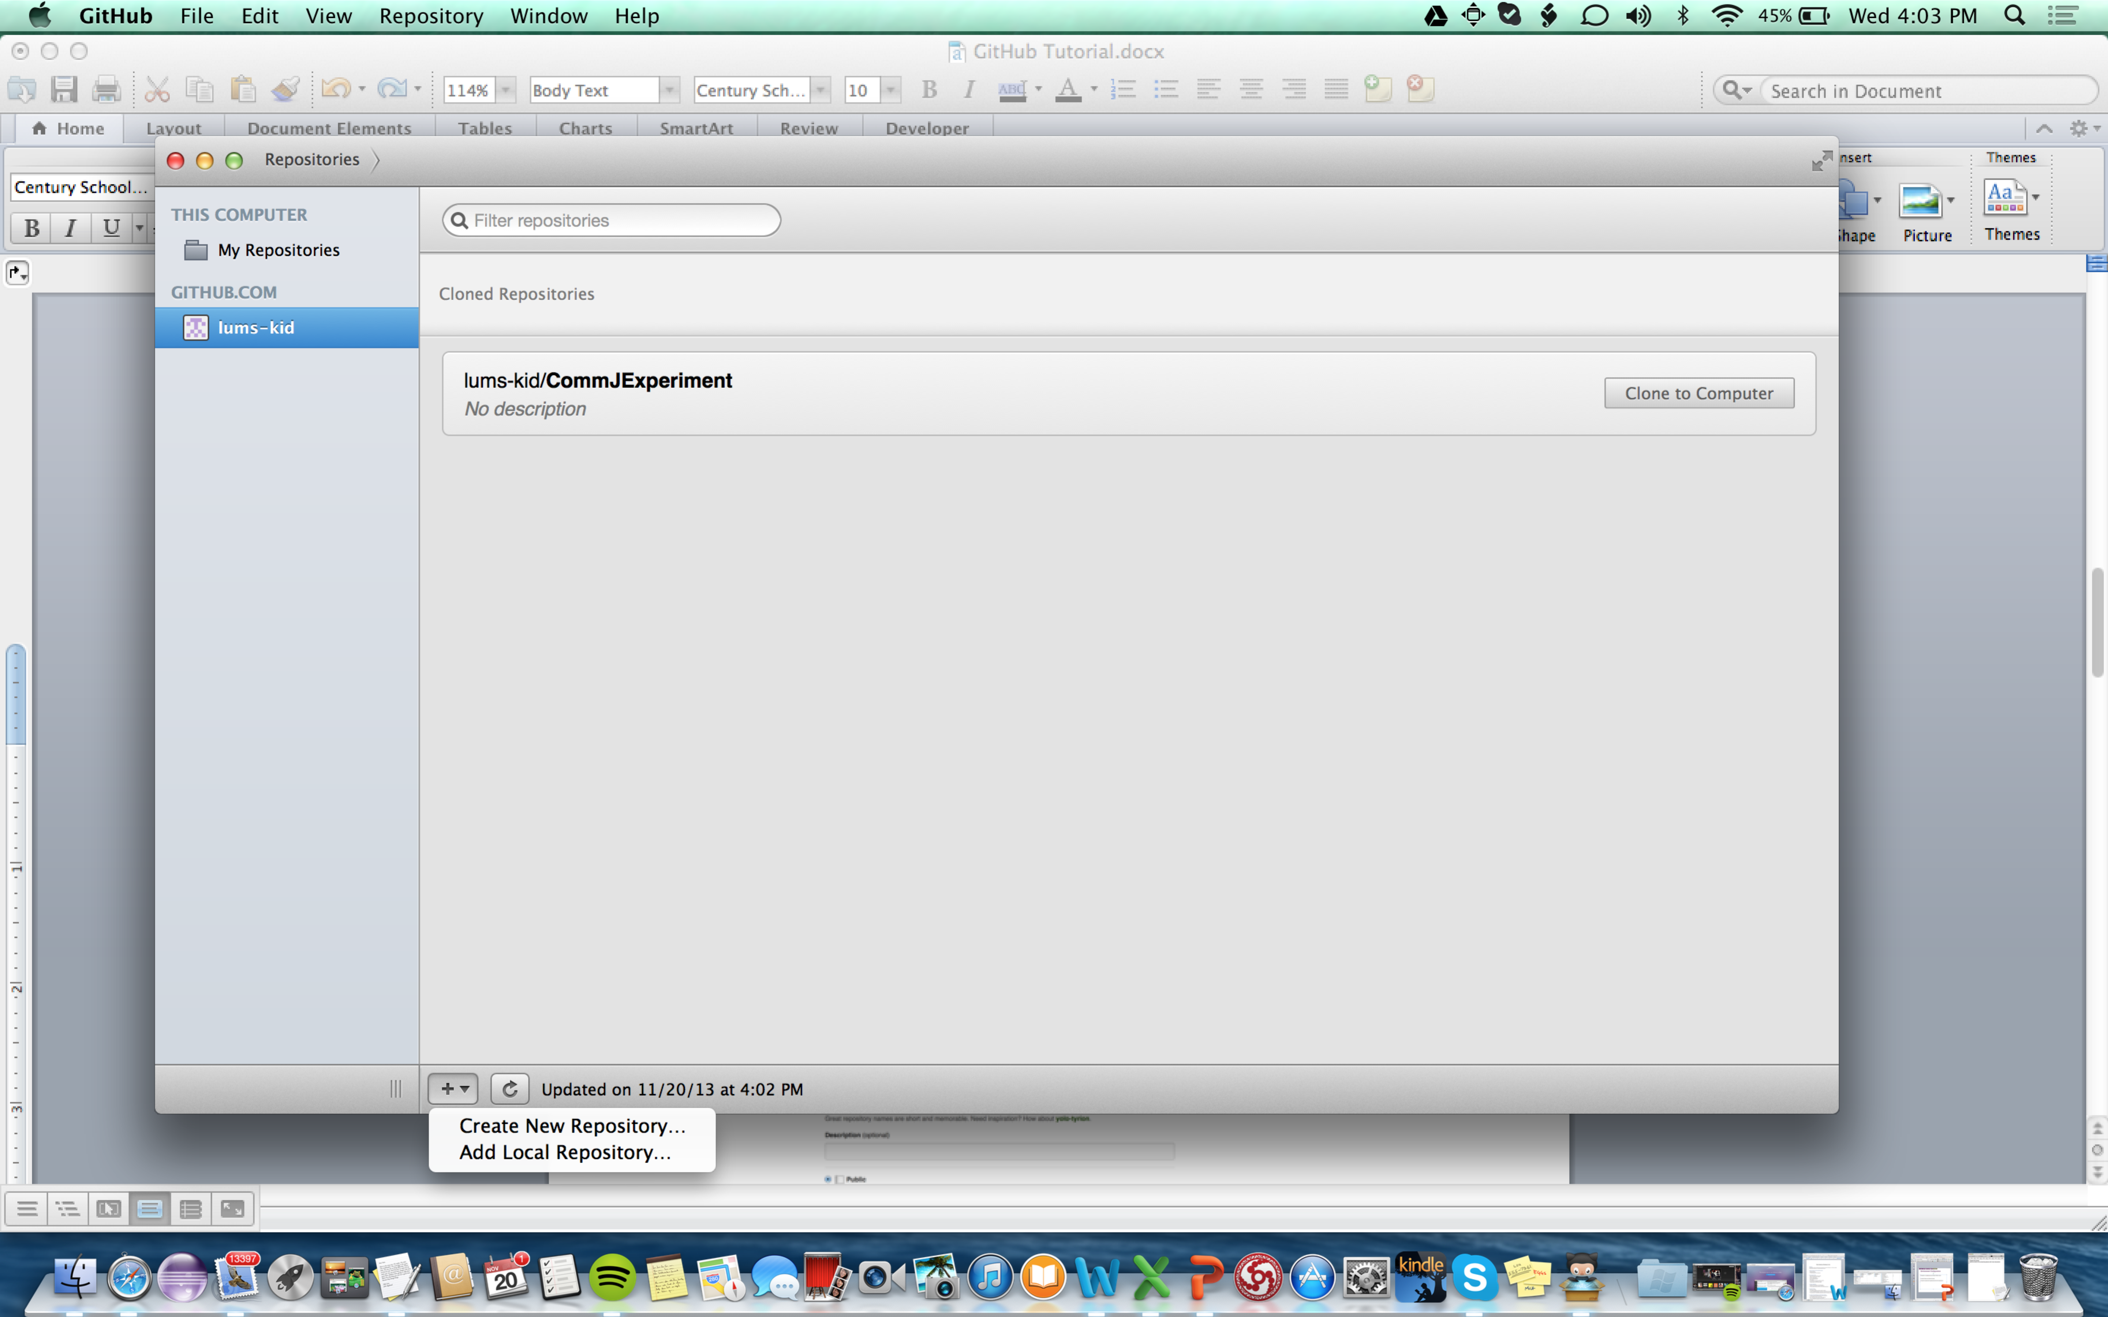

# Import existing code into your repository

* In the search box github.com in your browser, search for ali-raza-usu/CommJExperiment repository and download the zip
* Copy the zip contents inside your repository

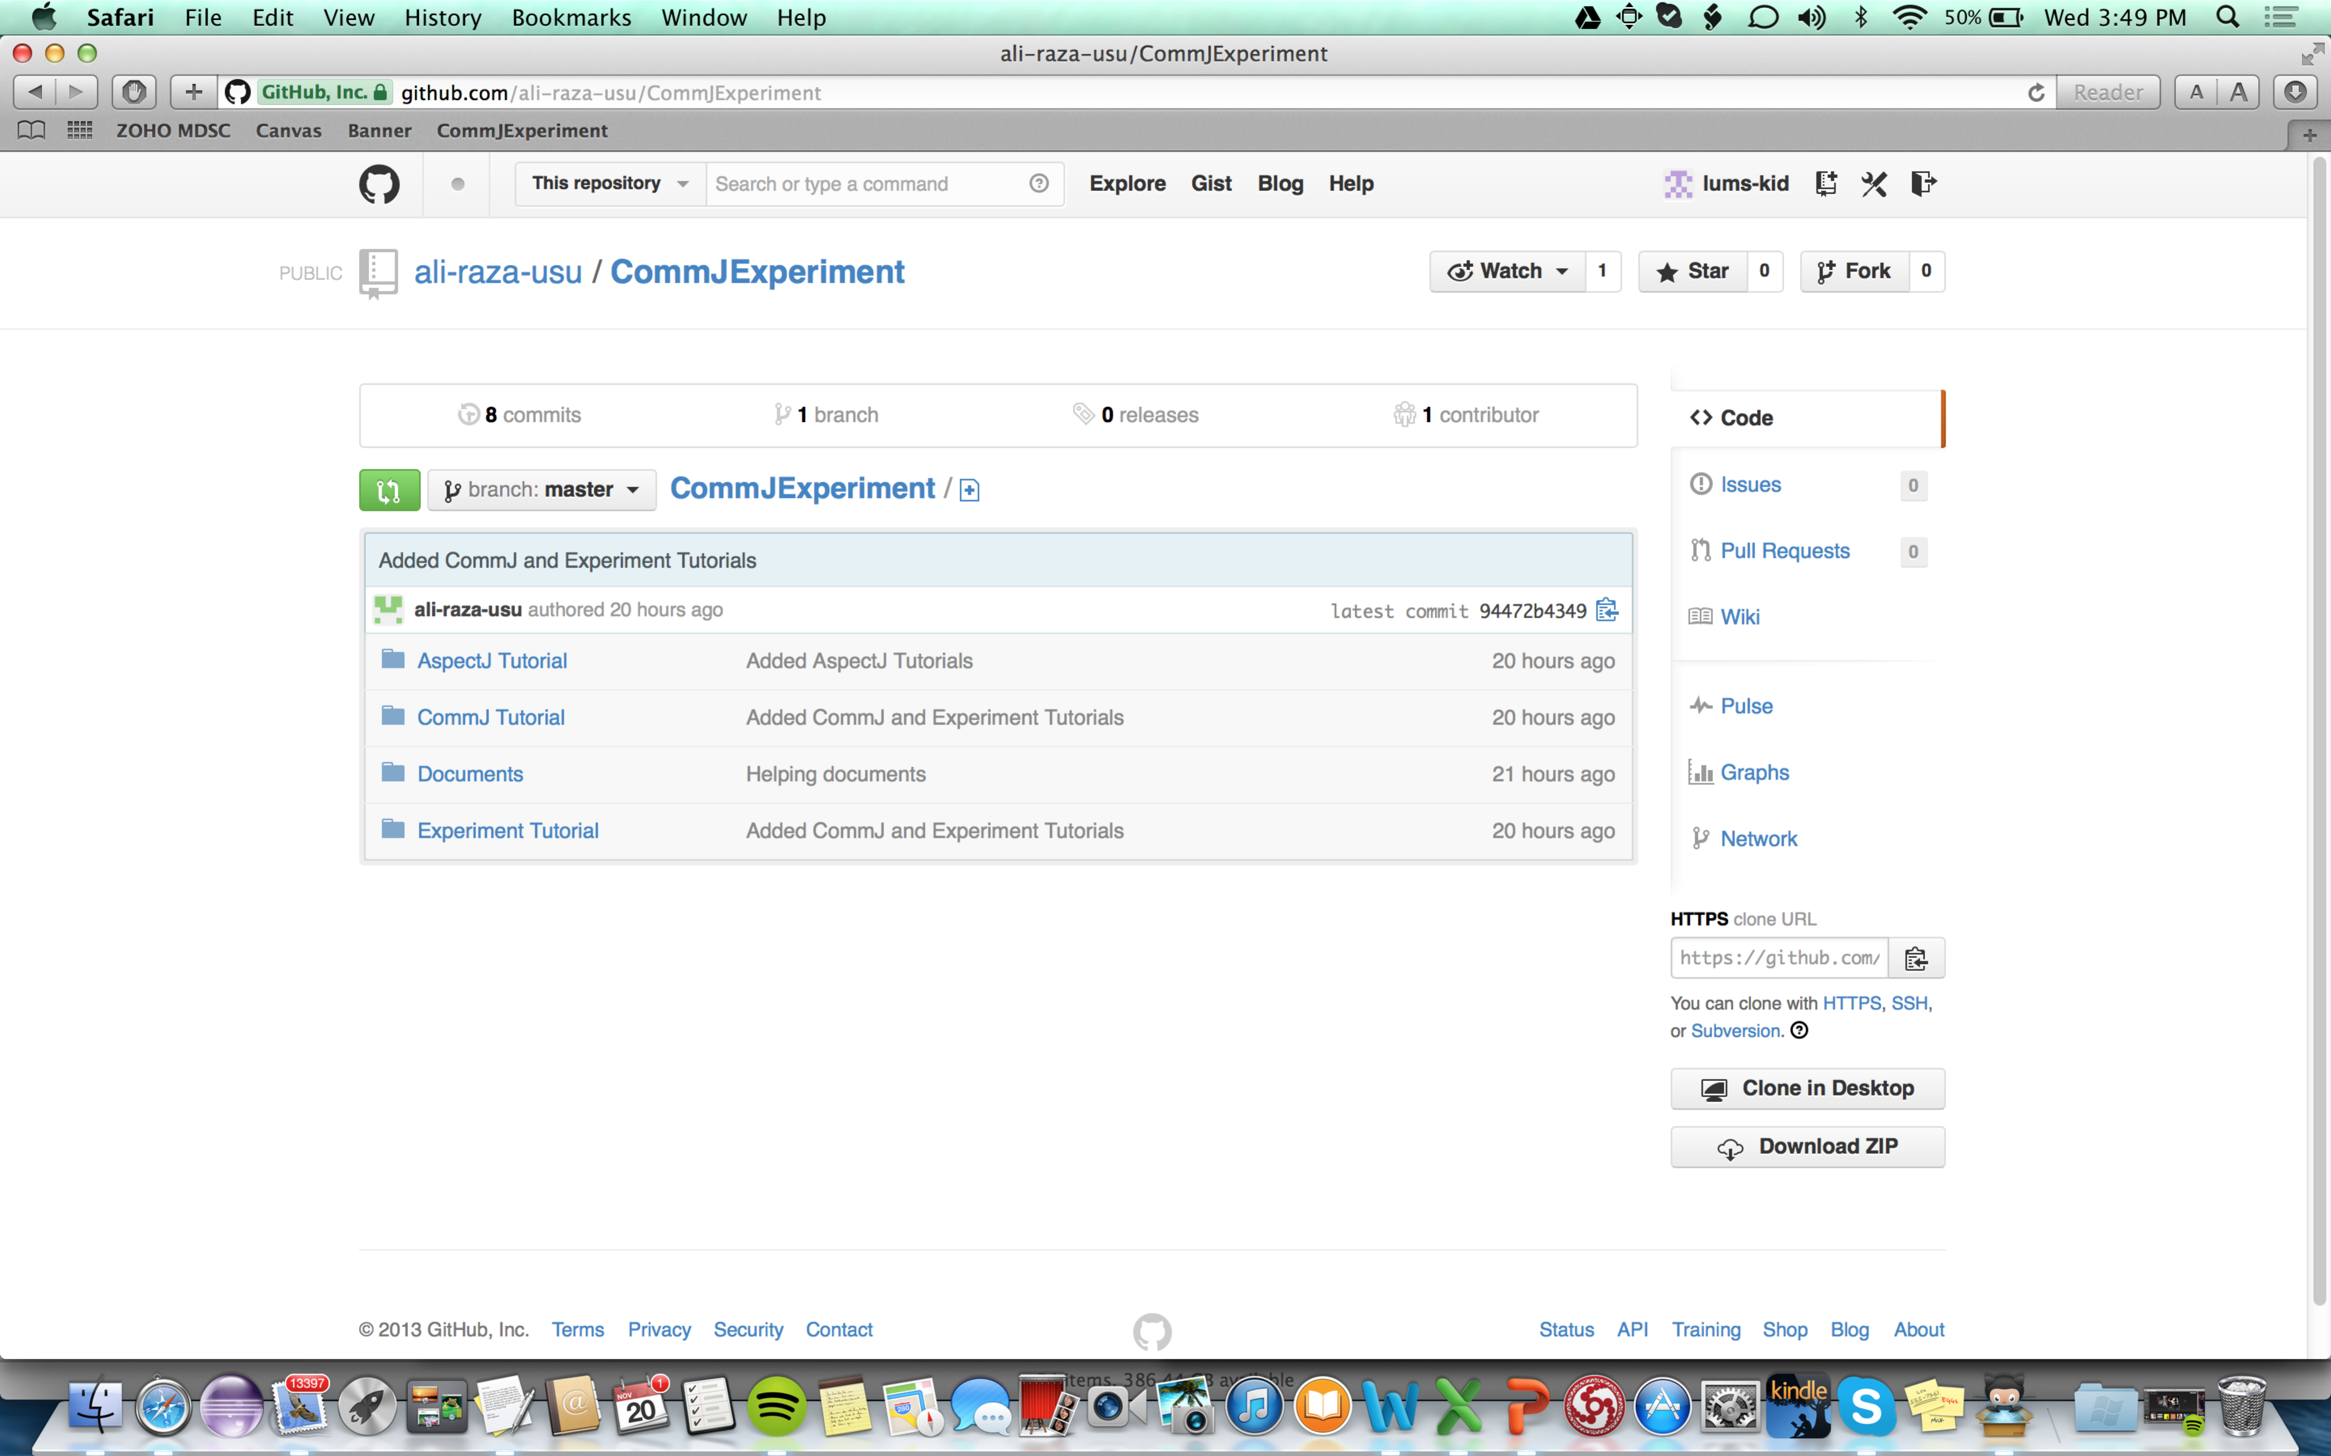

* Double click the repository and commit the changes as shown below.

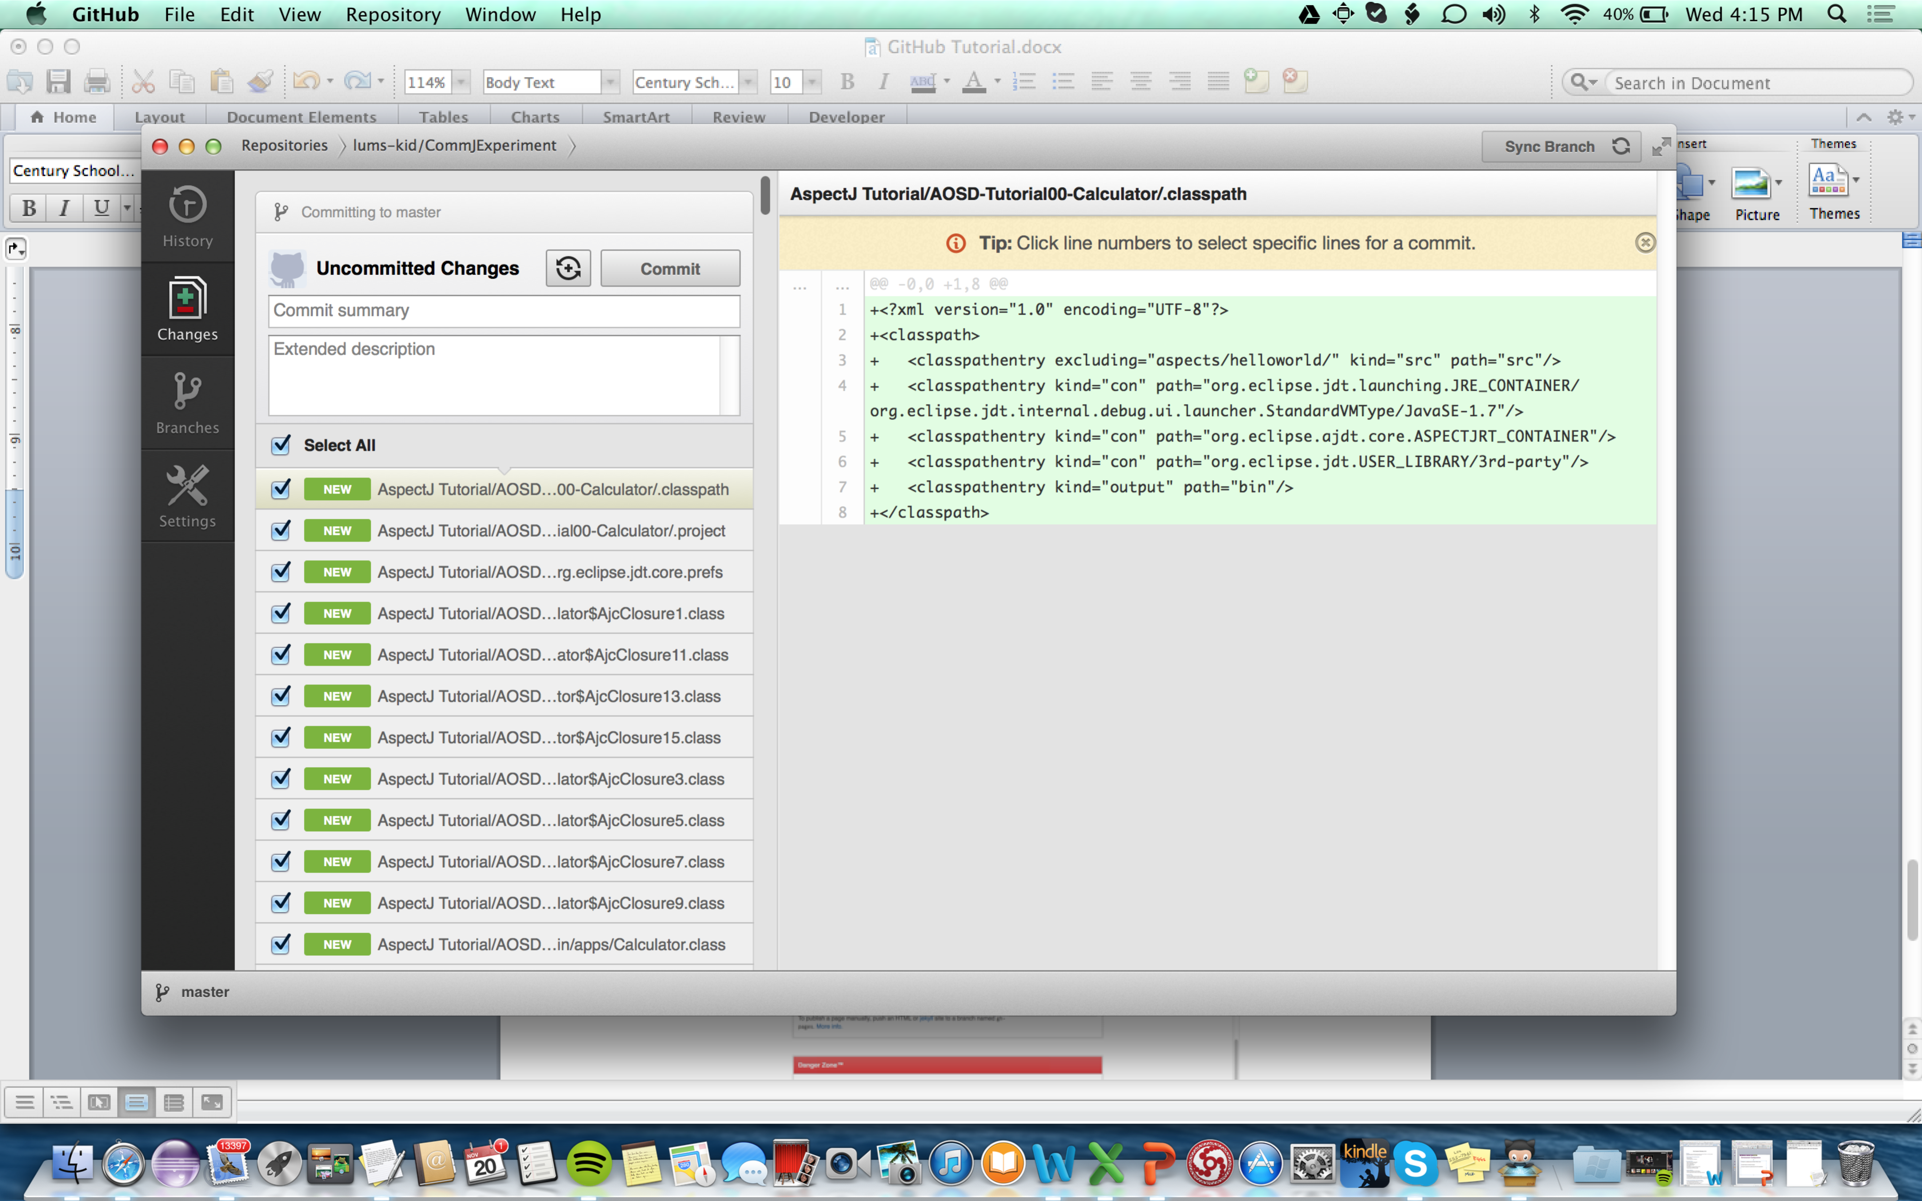

# Manage your code with branches

* For any significant milestone you can create a new branch and later switch to any branch as shown below.
* You can also merge your branches by selecting the Merge View from the top of the screen

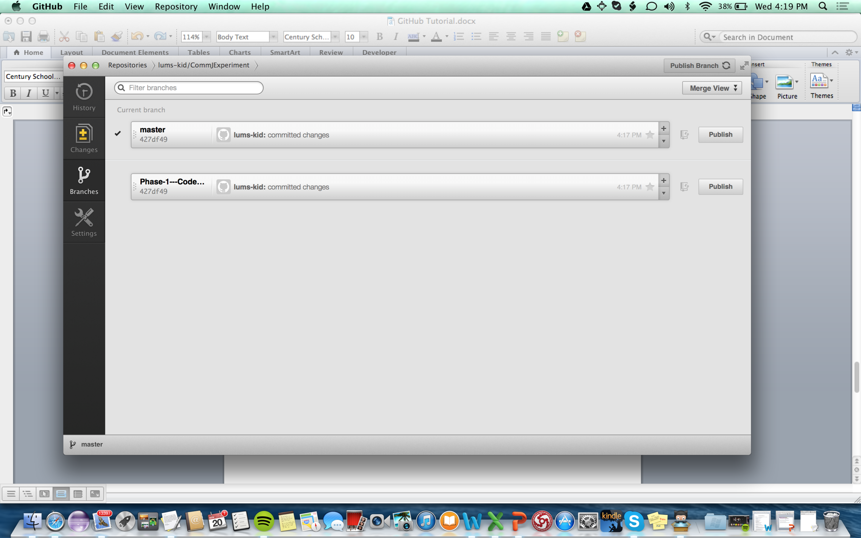

# Delete a Repository

* From the github.com, select the repository and from the right side select settings page. Then you can delete the repository from the bottom of the page.

